# [**‘Law & Order: SVU’ Showrunner Responds To Complaints About Kelli Giddish Exit: “Things Are More Complex Than They Appear”**](https://deadline.com/2022/08/law-order-svu-showrunner-kelli-giddish-exit-1235099670/)

By [Lynette Rice](https://deadline.com/author/lynette-rice/)

## [**Lynette Rice**](https://deadline.com/author/lynette-rice/)

*Senior TV Writer/TV Editor, Awards*

[@LynetteRice](https://twitter.com/LynetteRice)

#### **More Stories By Lynette**

* [FX Jumps Into Comedy Special Business With Stand-Up From Kate Berlant, Byron Bowers](https://deadline.com/2022/09/fx-comedy-specials-hulu-kate-berlant-bryan-bowers-1235117617/)
* [Jason Sudeikis Won’t Say If ‘Ted Lasso’ Is Going For A Fourth Season, So Quit Asking Him](https://deadline.com/2022/09/ted-lasso-fourth-season-jason-sudeikis-1235116895/)
* [What Quinta Brunson Really Thought Of Jimmy Kimmel Lying Onstage](https://deadline.com/2022/09/quinta-brunson-jimmy-kimmel-lying-on-stage-1235116835/)

[**VIEW ALL**](https://deadline.com/author/lynette-rice/)

August 24, 2022 3:28pm

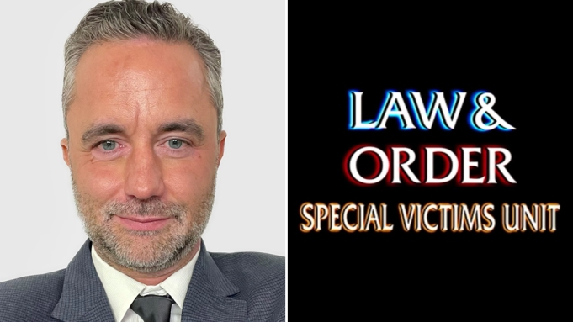

**David Graziano**Courtesy photo

Fans weren’t too happy to learn that [Kelli Giddish](https://deadline.com/tag/kelli-giddish/) is leaving [*Law & Order: SVU*](https://deadline.com/tag/law-order-svu/) after 12 seasons, so some went looking for someone to blame on social media. Fingers were pointed at Dick Wolf, but even new showrunner [David Graziano](https://deadline.com/tag/david-graziano/) was tagged in some messages by irate fans.

That’s when Graziano, who first responded to Giddish’s announcement on Instagram with a crying emoji, followed up with a comment of his own.

“You might take a moment to entertain the idea that things are more complex than they appear in a world of emojis and tweets,” he wrote on Giddish’s IG page. “All I’ll say is Kelli has handled this with the most incredibly classy comportment. She is, without a doubt, one of the finest industry professionals I’ve come across in my 24 years of writing for television. I’m saddened by her looming exit. It’ll be my lucky day if I ever get to write for her again.”

Deadline reported exclusively in June that [Graziano was named the new showrunner](https://deadline.com/2022/06/law-order-svu-david-graziano-showrunner-season-24-nbc-warren-leight-1235036371/) of *SVU*, replacing Warren Leight.

Earlier today, Giddish announced her plans to leave sometime during the 2022-23 season. She’s played Detective Amanda Rollins since 2011 and has been on the show for 12 seasons.

“I wanted to address the chatter I’ve seen online and let everyone know that this will, indeed, be my last season on Law & Order: SVU,” she said in a statement. “Playing Rollins has been one of the greatest joys and privileges of my life. I’ve been so fortunate to be a part of the Law & Order family for the last 12 years. There is simply no other character on TV like Rollins. She’s grown and changed, and I have as well. I started on this show when I was in my late 20s and I’m grateful I got to spend so many of my adult years with Rollins in my life.”

## **Must Read Stories**

HIDE ARTICLES

### [**UTA Promotes David Kramer To President, Jay Sures To Vice Chairman**](https://deadline.com/2022/09/uta-elevates-david-kramer-president-jay-sures-vice-chairman-agency-1235117344/)



### [**Shareholders OK Sale To Elon Musk As He Fights To Kill Deal; Whistleblower Testifies On Hill**](https://deadline.com/tag/twitter/)



### [**Analysis, Review, Best/Worst Moments, Red Carpet Gallery, Reaction & Winners**](https://deadline.com/tag/emmy-awards/)



### [**Pioneering French Director Of ‘Breathless’ Dies At 91; Tributes Pour In**](https://deadline.com/tag/jean-luc-godard/)



Subscribe to [**Deadline Breaking News Alerts**](https://cloud.email.deadline.com/signup) and keep your inbox happy.